**Homework 2:**

**1. Testing yourself on correlation:**

Can you describe the correlation implied by this graph. What can you learn from looking at outlying points.

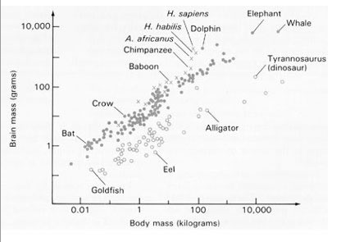

2. a. What factors explain the difference in the effects of genetic drift on gene frequencies in the three simulation graphs?

b. What would the graph look like if only selection was driving evolution?

You will have to put your thoughts into text if you submit in moodle.

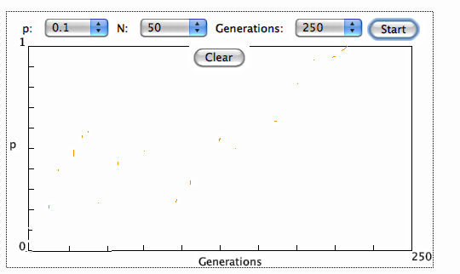

c. What would the graph look like if selection and drift were driving evolution? Again just explain if you are submitting in moodle.

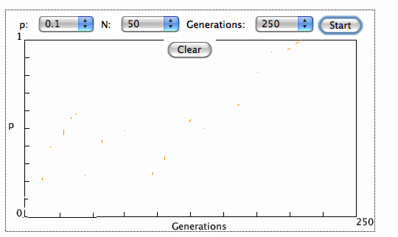

3.In which species do you feel the effects of genetic drift have been the greatest, Tasmanian devils, cheetah or Florida panthers? Defend your answer.